Solar cycle, period of about 11 years in which fluctuations in the number and size of sunspots and solar prominences are repeated. Sunspot groups have a magnetic field with a north and a south pole, and, in each 11-year rise and fall, the same polarity leads in a given hemisphere while the opposite polarity leads in the other. In each rise and fall, the latitude of sunspot eruption starts around 30° and drifts to the equator, but the magnetic fields of the follower spots (sunspots usually come in pairs, called leader and follower) drift poleward and reverse the polar field. In the next 11-year period, the magnetic polarities are reversed but follow the same pattern. Therefore, the magnetic period is 22 years.

Although sunspots were known as early as 1600, no one noticed that their number changed with time until the German amateur astronomer Samuel Heinrich Schwabe announced the 11-year cycle in 1843. Swiss astronomer Rudolf Wolf studied historical sunspot records and proposed the scheme still used for numbering solar cycles, with solar cycle 1 beginning in 1755, the earliest year for which he found reliable sunspot numbers. The 22-year magnetic cycle was discovered in 1925 by the American astronomer George Ellery Hale.

Solar minimum events and approximate dates

Event Start End

Homeric minimum[6] 950BC 800BC

Oort minimum 1040 1080

Medieval maximum 1100 1250

Wolf minimum 1280 1350

Spörer Minimum 1450 1550

Maunder Minimum 1645 1715

Dalton Minimum 1790 1820

Modern Maximum 1914 2008

Unspecified 2009 present

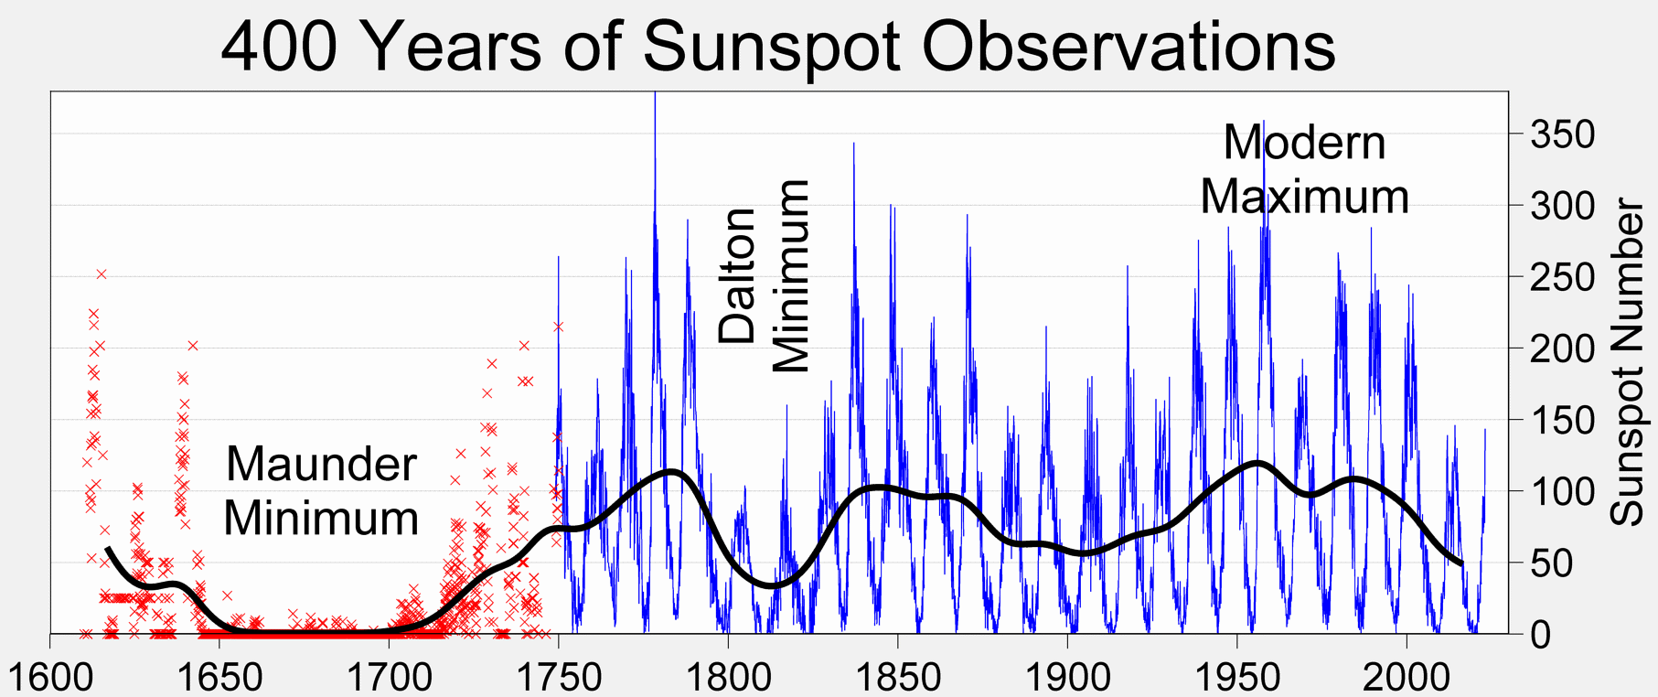

Data sources:

Sunspots: <https://www.sidc.be/uset/searchForm.php> (sidc, white, processed)

<https://kso.iiap.res.in/new/archive/input> (kso, white, unprocessed, 8/2011)

<https://sdo.gsfc.nasa.gov/data/aiahmi/>

<https://celestialscenes.com/alma/coords/CoordTool.html>

Conformation(non-image data) - <https://www.aavso.org/data-access>. Personal observations, <https://www.spaceweatherlive.com/en/solar-activity/solar-images/sdo.html>(image data)

<https://soho.nascom.nasa.gov/data/software.html> (pocbl software for data analysis, soho)

<https://data.nas.nasa.gov/helio/portals/solarflares/datasources.html> : Advanced

Sunspots - Visible & H alpha wavelengths

Solar prominences - Visible & EUV, X-ray

SOHO

1. Sunspot prediction paper - Used MacIntosh classification systems, wolf number & MAE in train model, took 1819-2019 data. Test 2021-2025, highly accurate model as per graphs. Used RNN type of neural network. LSTM is architecture for RNN
2. Solar flare index - XGBoost & Random forest better than KNN, take a look at selected AR on the sun, Tflare formula,used RMSE metric. Preferred Manhattan distance metric over euclidian, minkowski. RF is best model to build Tflare & Mflare predictions 0.95 accuracy.Hyperparameter tuning?
3. Solar flare prediction - According to their X-ray emissions at a wavelength of 0.1 to 0.8nm, solar flares are classified as A, B, C, M, and X classes.
4. 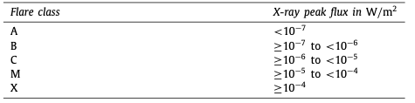

Compares 3 ML methods, RF, SVM, LGBM

Dataset separation

1. Download sunspot data from sources: https://www.ngdc.noaa.gov/stp/solar/ssndata.html
2. Extract all minima data

i) Convert file to suitable format

ii) Extract minima data from that

iii) Store that data properly

1. ML model
2. Infer activity of the sun in that period

**Literature Review of various papers found through Google Scholar::**

1. Comparative analysis of different ML models used to predict sunspot data based on MAE & RMSE of the predictions. [KNN, random forest, LGBM, XGBoost]
2. Use of deep neural networks & RNN for prediction of sunspots
3. For sunspot trend analysis people have used Bayesian analysis, time series analysis by fourier transform, wavelet analysis.
4. Using deep learning on sunspot images itself & comparison of region & area of region with actual observations & finding out their accuracy.

These above methods are very commonly found in many papers published till date. Below are some unique & interesting papers. But these use image data for position of sunspots

1. Prediction of sunspot cycle 25/26 period using ML & spectral analysis(this has nothing to do with spectra of sun). They looked at hemispheric sunspot number prediction & concluded southern has more activity than northern region.
2. Studies of Dalton minimum[clearly see that the sunspots appear at high latitudes at the beginning of the solar cycle and at low latitudes toward the end of the solar cycle, which is a typical feature of sunspots. It is clear that during the Dalton minimum there is no particular sunspot asymmetry between the northern and southern hemispheres as seen during the Maunder minimum, and we also found that there is no clear active longitude during the Dalton minimum] then constructed magnetogram using those drawing.
3. Relationship between solar wind speed and sunspot cycle. [Georgieva ([2011](https://iopscience.iop.org/article/10.3847/1538-4357/acfc21/meta#apjacfc21bib15)) shows that the time between the sunspot maximum and geomagnetic activity maximum on the sunspot declining phase is the time that takes the solar surface meridional circulation to carry the remnants of sunspot pairs from sunspot latitudes to the poles. The relationship between sunspots and solar wind requires exploration.] There is time delay between the sunspot number peak & strongest solar wind.[large amplitude high-speed solar wind streams are more commonly observed in years of declining and minimum solar activity than near solar maximum, directly related to the long-term evolution of coronal holes (CHs)]
4. Gleissberg centennial cycle( a maximum of Cycle 25 below the average and, on the other hand, a lower peak than the preceding ones for Cycle 26, suggesting that Solar Cycles 24, 25, and 26 are part of a minimum of the centennial Gleissberg cycle, as occurred with Cycles 12, 13, and 14 in the final years of the 19th century and the early 20th century).

Data Sources:

Belgium observatory, NOAA, SIDC for image data

Other parameters - <https://www.sidc.be/SILSO/datafiles>

<https://geomag.bgs.ac.uk/data_service/data/magnetic_indices/apindex.html> <https://www2.mps.mpg.de/projects/sun-climate/data.html> <https://lasp.colorado.edu/lisird/data/penticton_radio_flux>

Prominent Journals where published:

Advances in Space Research, Solar Physics, Astrophysical Journal, Astronomical Society of Japan

Out of Scope

1. Analysis of 5 cycles using DST number - number of geomagnetic storms (GmS) tends to be slightly higher in odd-numbered solar cycles compared to even-numbered cycles. number of GmS is significantly higher during the downward phases of solar cycles compared to the upward phases. Their results are consistent with existing knowledge.